PSPRadio

Skins Guide

(Compatible with Release 0.37 Final)

Compiled by albadross (David Dew)

Version 2.0 |  | 14 January 2006

THE SELECTOR SKIN (Selector 2.0.zip)

The Main Playback Screen | The Shoutcast Screen
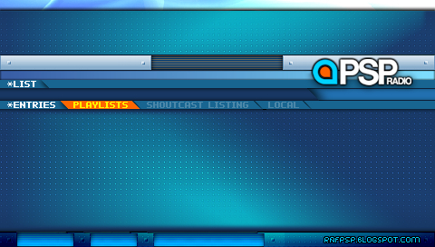 | 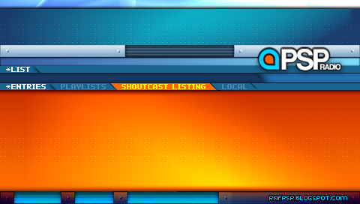
The Local Files Playback screen | The Options Screen
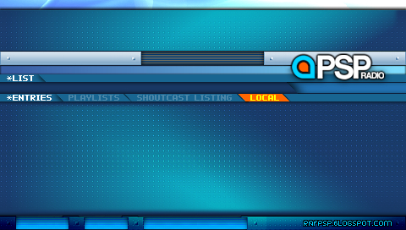 | 

THE STAGESHOW SKIN (Stageshow 2.0.zip)

The Main Playback Screen | The Shoutcast Screen
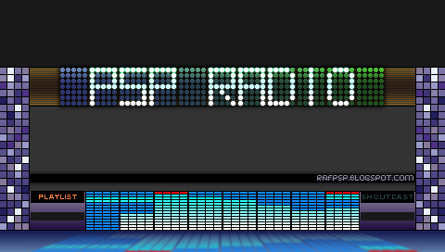 | 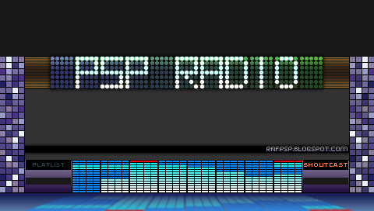
The Local Files Playback screen | The Options Screen
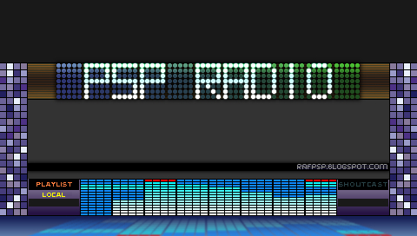

THE METALLE SKIN (Metalle 2.0.zip)

The Main Playback Screen | The Shoutcast Screen
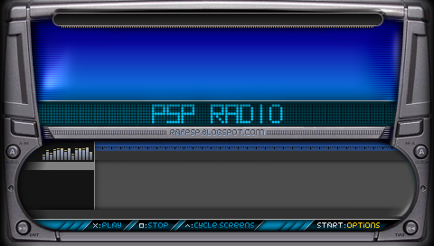 | 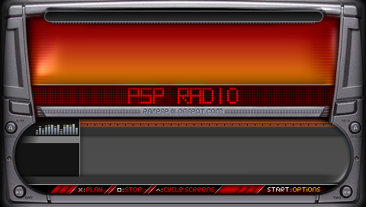
The Local Files Playback screen | The Options Screen
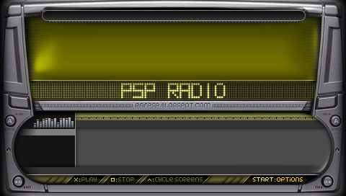

HOW TO USE THESE SKINS

These skins have designed to work with PSPRadio 0.37 Final.

They have each been neatly grouped into their own zip file, the name of which is shown by the title of the skin).

All you have to do is to unzip the contents of one of these zip files into the TextUI folder of the PSPRadio program.

The next time you run the program, your new skin should appear.

EXPERIMENT

Don’t worry about playing with the cfg and png files.

You do do it at your risk. But that was how I learnt!

CREDITS

These skins could not exist without the endless help that Semtex has given me.
His creative influence is stamped all over these skins.

